30-7-24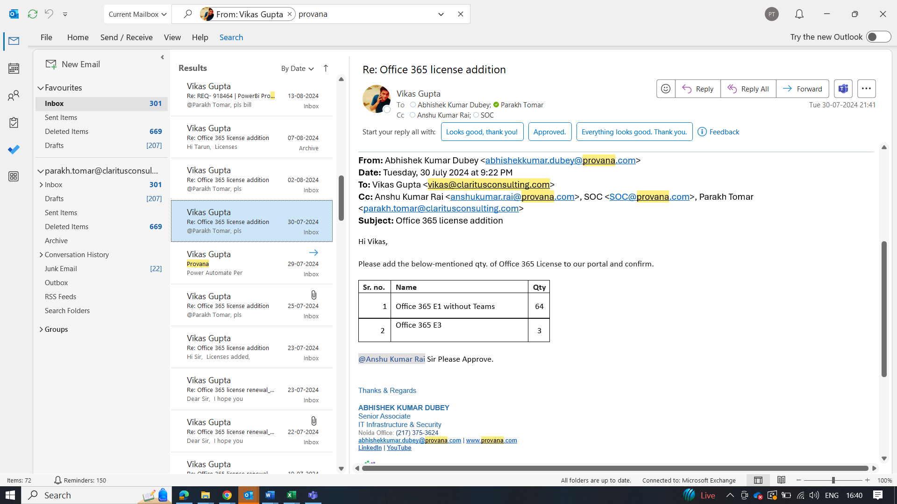

2-8-24

7-8-24

13-8-24

27-8-24

4-9-24

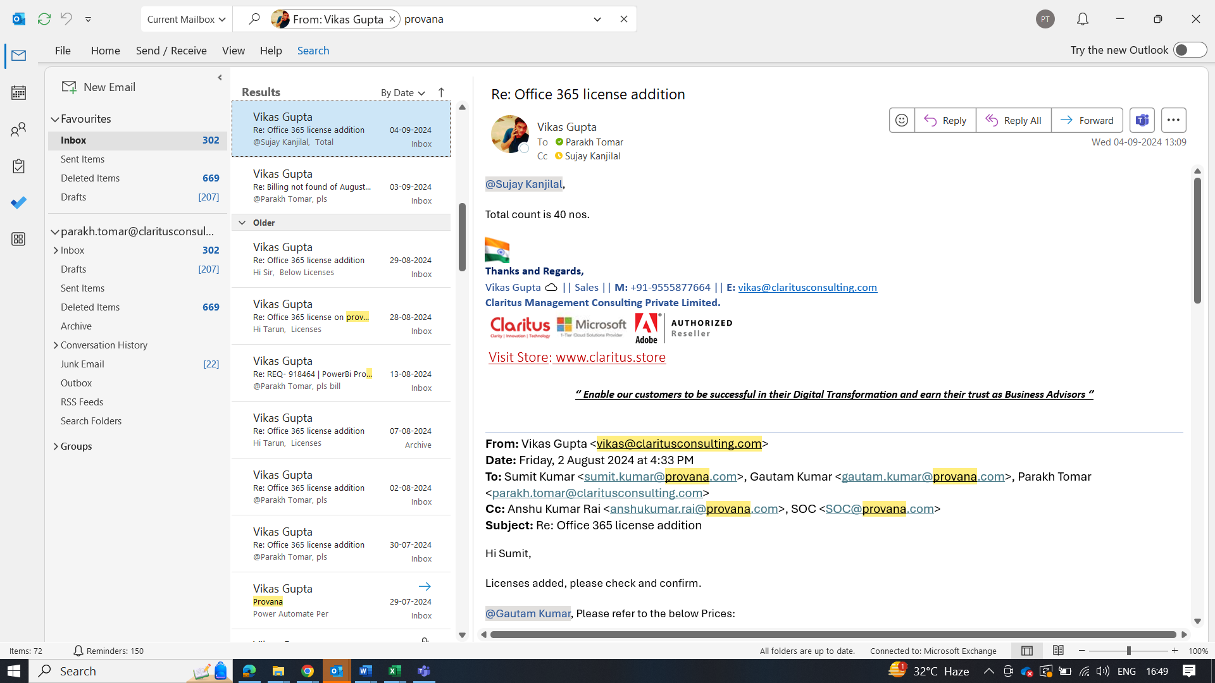

4-9-24

**5-9-24**

**5-9-24**

**5-9-24**

**9-9-24**

**12-9-24**

**17-9-24**

**24-9-24**

**12-9-24**

|  |  |  |  |  |  |  |
| --- | --- | --- | --- | --- | --- | --- |
| SKU Description | August | 30-09-2024 | 02-08-2024 | 07-08-2024 | 13-08-2024 | 27-08-2024 |
| Visio Plan 2 | 12 |  |  |  |  |  |
| Microsoft 365 Business Basic | 300 |  |  |  |  |  |
| Microsoft 365 Business Basic (no Teams) | 300 |  |  |  |  |  |
| Microsoft 365 Business Standard (no Teams) | 300 |  |  |  |  |  |
| [Microsoft 365 Business Standard](https://partner.microsoft.com/dashboard/v2/customers/72c490b4-b8a8-4d0c-9915-f6b23e15b7f5/subscriptions/f1e4bca8-8361-4a16-d399-3a99bfa6ba83) | 300 |  |  |  |  |  |
| Microsoft 365 Apps for business | 84 |  |  |  |  |  |
| Office 365 E3 | 186 | 3 |  | 8 |  | 5 |
| Exchange Online (Plan 1) | 72 |  |  |  |  |  |
| Microsoft 365 F1 (no Teams) | 145 |  |  |  |  |  |
| Office 365 E1 (no Teams) | 1216 | 64 |  |  |  |  |
| Office 365 E1 | 45 |  | 10 |  |  |  |
| Power BI Pro | 22 |  |  |  | 6 |  |
| Microsoft 365 Business Premium | 300 |  |  |  |  |  |
| Power Automate per user plan | 1 |  |  |  |  |  |
| Power Automate Premium | 1 |  |  |  |  |  |
| Power BI Premium Per User | 5 |  |  |  |  |  |